**Electric Vehicle Population in the State of Washington**

DATA AND ITS PRE PROCESSING:

The analysis is done on the basic of two different datasets. The first one contains statistics on registered electric vehicles in the state of Washington. The data was obtained from the data.gov website of the United States federal government. This dataset has in all 17 columns and 109026 entries with 10 objects, 6 integers and 1 float data types.

The second dataset contains data about the number of electric vehicles that were registered by the Department of Licensing every month. This data was also obtained from the data.gov website of the United States federal government. This dataset has in all 10 columns and 15817 entries with 4 objects, 5 integers and 1 float.

After loading both the datasets we cleaned the sets by limiting the data to Washington state and removed the vehicle type “Trucks” from the set as we don’t have electric trucks available and it makes data easy to read and process.

Dataset links:

<https://catalog.data.gov/dataset/electric-vehicle-population-data>

[https://catalog.data.gov/dataset/electric-vehicle-population-size-history-by-county](https://catalog.data.gov/dataset/electric-vehicle-population-size-history-by-county%20)

METHODS OF ANALYSIS:

1. To find out the best car which can travel more distance in a single charge, we did group by of car model and used the maximum function to find the car which travels the maximum distance and sorted the values in descending order from that we got to know that tesla model S has the maximum range of 337 miles.

2. We found out the most popular car in the electric cars and calculated the percentage of number of cars sold by each company out of the total number of electric cars by only selecting make column in the dataset and using value.counts function to calculate the number of cars produced by each company and we also used pie chart to depict the results, out of which we got tesla is producing 57.4% of total electric cars.

3. We identified the trend of the electric cars over the past 50 years by comparing the sales of cars in each year to get this we selected the column model year and used an aggregate function size to get the number of electric cars sold in each year and depicted the results in a bar graph from the graph we got to know that over the past 5 years there is a huge jump in the sales of electric cars 2022 had the most electric cars sold.

4. We compared the two types of electric cars BEV(Battery Electric vehicle) and PHEV(Plug in hybrid electric vehicle) based on their Electric Range, on the y axis we took the electrical range and on the y axis we took the CAFV eligibility, so from the analysis we got to know that BEV vehicles travel the more distance when compared to PHEVS as they have smaller batteries.

5. At last we took the initial data set to just calculate the no of electric cars sold in each state by grouping by the state column and using the aggregate function size to calculate from that analysis we got to know that Washington state is leading with the electric car sales followed by California state.

DESCRIPTION OF PYTHON PROGRAM:

import pandas as pd

data = pd.read_csv("/Users/segurithvik/Downloads/Electric_Vehicle_Population_Data.csv")

df = pd.DataFrame(data)

df

**#to read the data from the csv file**

df.drop(df[df['State'] != "WA"].index, inplace = True)

**#Cleaning the Dataset 1 Dropping the data which is not from the State of Washington**

df2.drop(df2[df2['Vehicle Primary Use'] == "Truck"].index, inplace = True)

**#dropping trucks from vehicle primary use column.**

df3 = pd.merge(df, dataWA)

**#merging the data sets**

max_range = df3.groupby('Model').max()[['Electric Range']].sort_values('Electric Range', ascending=False)

# **group by of car model and used the maximum function to find the car which travels the maximum distance and sorted the values in descending order**

df3['Make'].value_counts()[:5]

**# List of top 5 brands manufacturing EVs**

fig = plt.figure(figsize=(6,6), dpi=125)

ax = plt.subplot(111)

data['Make'].value_counts()[:5].plot(kind = 'pie', ax=ax, autopct='%1.1f%%',startangle=0, fontsize=10)

**# Pie chart showing the top 5 brands manufacturing electric vehicles.**

dataaa= df2.pivot_table(index = ['State'], aggfunc ='size')

dataaa = dataaa.sort_values(ascending = False)

**# grouping by state column and counting the values, of number of cars sold by each state**

cars_sold_by_year= df3.pivot_table(index = ['Model Year'], aggfunc ='size')

cars_sold_by_year

**#grouping by model year column and calculating the number of e cars sold in each year.**

plt.figure(figsize=(15,15))

ax = sns.countplot(x="Model Year", data=df3)

plt.ylim(50, 1400000)

**#Plotting the graph for increase in demand of EV's.**

sns.relplot(x="Clean Alternative Fuel Vehicle (CAFV) Eligibility", y="Electric Range",height=6, hue="Electric Vehicle Type",data=df3)

**#plotting the graph between electric range and cafv eligibility**

**OUTPUTS:**

ANALYSIS 1 –

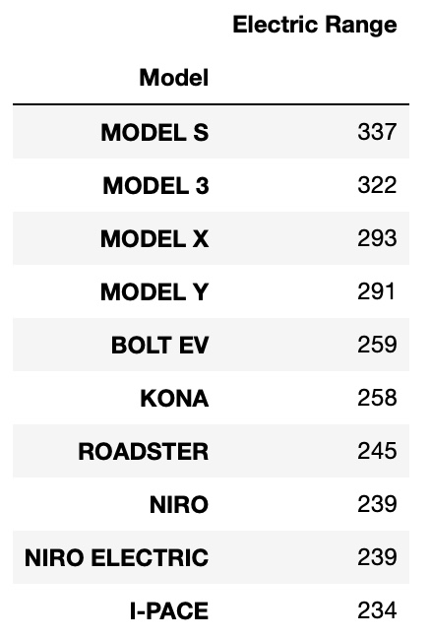

ANALYSIS 2 –

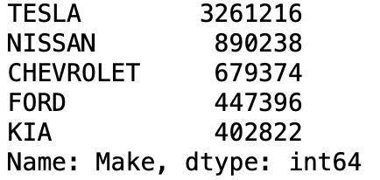

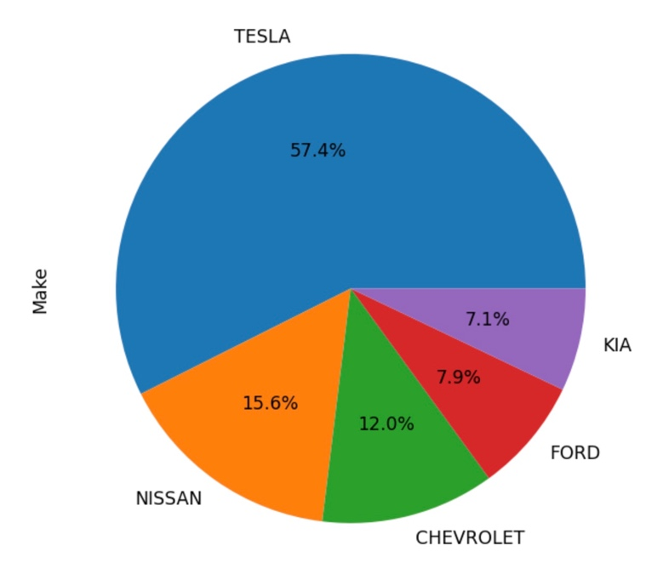

ANALYSIS 3 –

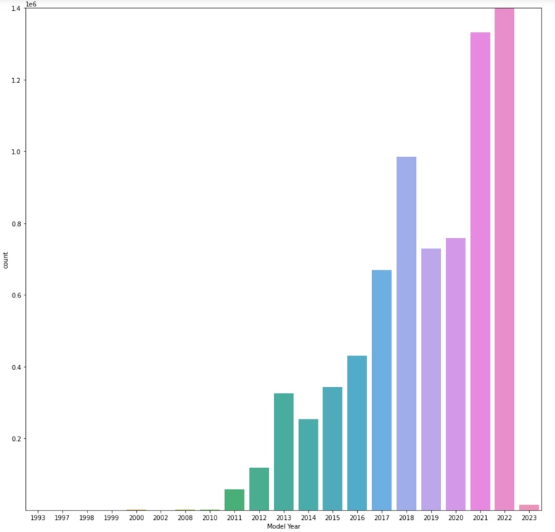

ANALYSIS 4-

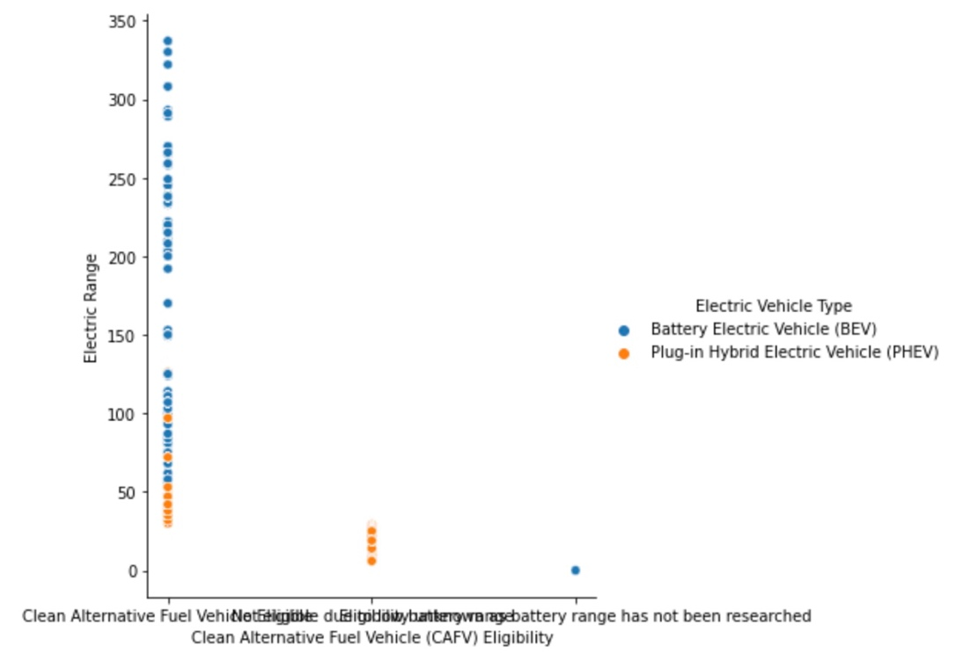

ANALYSIS 5 –

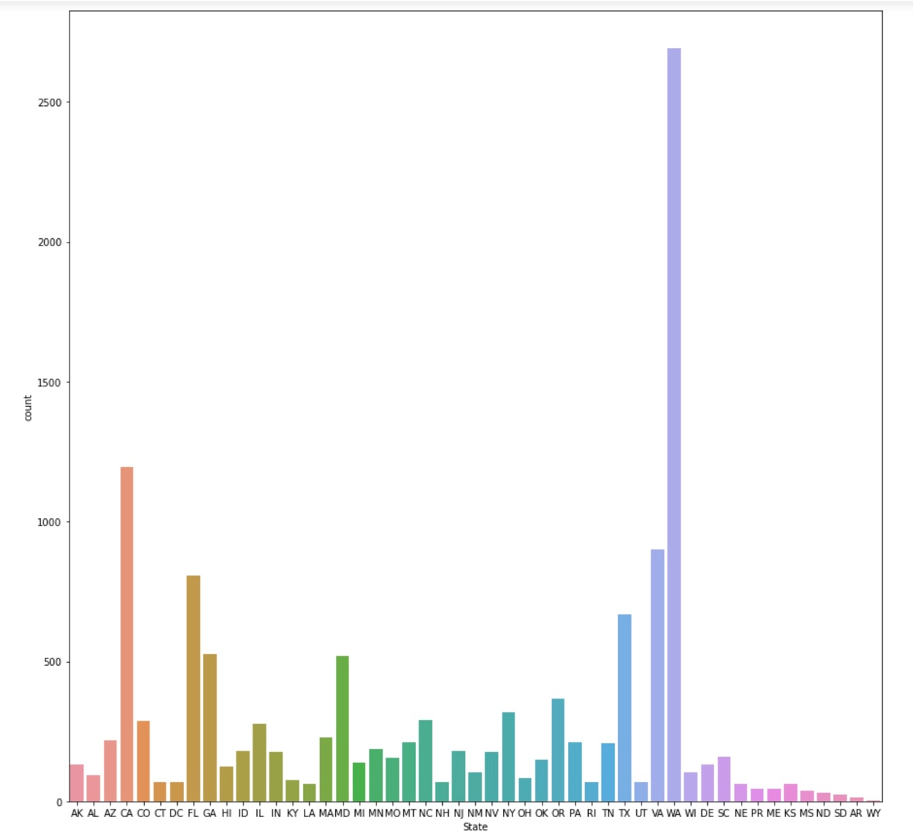

**CONCLUSION:**

From our analysis we got to know that tesla model S travels the maximum range with 337 miles, Tesla company produces the most number of electric cars with 57.4% cars from the total EV sales followed by Nissan and Chevrolet with 15.6 and 12 percent respectively. The trend of electric cars over the past 50 said us that the sales have been massively increased in the last 5 years should have gone sky high in 2020 and 2021 but due to covid the number of electric car sales did not increase drastically and in 2023 also due to the chip shortage companies are unable to manufacture more number of cars, so in the coming two to three years we will see even more bigger jump in the sales of electronic vehicles as people are more concerned about the environment and also the production of PHEV type electrical cars have decreased as they have less distance range than BEV electric type cars. Finally the sales of electrical cars are highest in Washington state when compared to the other states in the country and Tesla company is way too ahead than other companies in the electrical car industry.

Group members contribution:

Rithvik did the data cleaning and the initial steps , analysis 3,4 and Pavan kumar did the analysis 1,2 and for analysis 5, ppt and report both of us did it together and helped each other’s during the project.